Synthetic Nanozymes for Enzyme-Like Catalysis
and Intracellular Prodrug Activation

Rabia Zahid,¹ Ariadna Lázaro,² María Sancho Albero,³ Pierre Picchetti¹

¹Karlsruhe Institute of Technology (KIT), Institute of Nanotechnology (INT), Germany;
²Karlsruhe Institute of Technology, Institute of Functional Interfaces (IFG);
³Instituto de Nanociencia y Materiales de Argaón (INMA), CISC-Universidad de Zargaoza

e-mail: rabia.zahid@partner.kit.edu

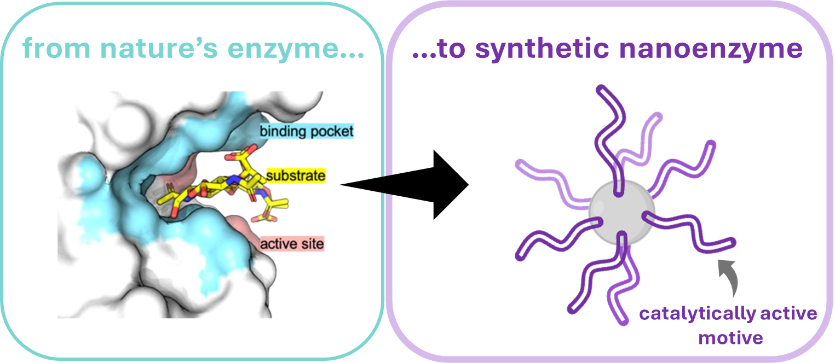

The design of enzyme-mimicking nanoparticles using supramolecular chemistry offers strong potential for improving biochemical sensing and catalysis [1]. We present a new type of ultrasmall organosilica nanoparticle (∼2 nm) functionalized with surface groups that engage in host–guest interactions, especially with macrocycles like cucurbit[7]uril (CB7) [2]. These nanoparticles include cavities that selectively bind analytes. When an analyte is introduced, it displaces the macrocycles, causing measurable changes in nanoparticle aggregation and catalytic behavior. This interaction supports both sensitive detection and enzyme-like catalytic activity, mimicking the dynamic response of natural enzymes. Our system relies on the host–guest interaction between CB7 and the nanoparticle to recognize analytes such as drugs or bioamines. The analyte-induced aggregation changes are easily monitored through light scattering. Moreover, CB7 displacement activates the catalytic sites on the nanoparticles. These organosilica materials demonstrate potential in host–guest chemistry due to their chemical responsiveness. Combining simple, low-cost components with precise molecular design provides new opportunities for creating functional nanomaterials.

References
[1] a. X. Ji et al., Adv. Mater. 2022, 34, 2201562; b. K. Korschelt et al., Chem. Eur. J. 2018, 24, 9703–9713;
c . P. Maag et al., Macromolecules. 2022, 55, 0024-9297
[2] a. W. Freeman et al., J. Am. Chem. Soc. 1981, 103, 7367–7368; b. K. I. Assaf, W. Nau, Chem. Soc. Rev. 2015, 44, 394–418.

