**Micellar Encapsulation of Triphenylene NHC Gold(I) Complexes**

Anyie P. Atencio1, Mounsef Lahboubi2, Inmaculada Angurell1, Joaõ Carlos Lima3, Kristin Bartik2, Laura Rodríguez1

1Department of Inorganic and Organic Chemistry, Universitat de Barcelona, Martí Franquès 1-11, 08028 Barcelona (Spain)

2Laboratoire de Chimie Organique, Université libre de Bruxelles (ULB), Avenue F.D.  
Roosevelt 50, CP160/06, B-1050 Brussels (Belgium)

3LAQV-REQUIMTE, Departamento de Química, Universidade Nova de Lisboa,  
Monte de Caparica (Portugal)

*e-mail: aatences19@alumnes.ub.edu*

In recent years, gold(I) N-heterocyclic carbene (AuI–NHC) complexes have emerged in a wide variety of optoelectrical materials[1] due to the synergy of two factors: the possibility of tuning the electronic and luminescence properties through aurophilic Au⋯Au interactions and the carbenes structural characteristics that allow the modulation of both the steric and electronic properties[2,3]. The main chemical properties responsible of this can be their incredibly strong sigma donor capacity, and the fact that a broad range of different substituents can be attached to the nitrogen atoms. In a previous research, interesting results were obtained with alkynyl gold(I) complexes using triphenylene as a chromophore. It is known that the functionalization of the triphenylene core with chains containing different functional groups offers many opportunities to modulate the behavior of the system while conserving the tendency to columnar organization which opens the possibilities for π-stacking interactions[4].

It can be also possible to incorporate the gold(I) complexes into confined spaces, such as micelles. The resulting system will display new properties such as: i) solubility of gold complexes in aqueous media, which enhances their applications in biological sensors; ii) room-temperature phosphorescence (RTP) which mean that confinement suppresses the non-radiative decay process and consequently it is a feasible strategy to improve the phosphorescence emission of gold(I) complexes.

Taking all of this into consideration, in this work we present the synthesis of two different series of triphenylene gold(I) carbene complexes and a systematic study of their encapsulation and photophysical properties.

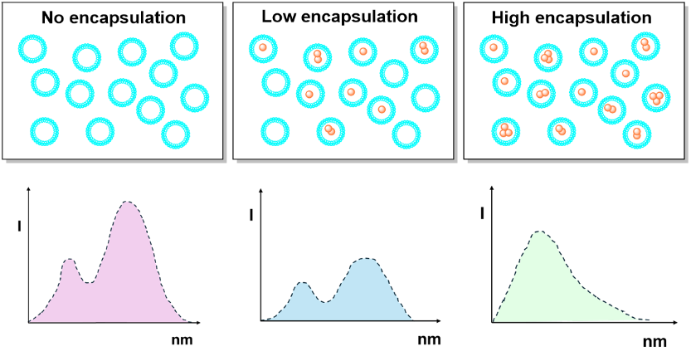

***Figure 1.*** *Scheme of the* *effect of encapsulation on the fluorescence emission.*

**References**

[1] Pinto, M. Echeverri, B. Gómez-Lor, and L. Rodríguez, *Dalton Trans.,* **2022**, *51*, 8340-8349.

[2] A. Johnson and M. C. Gimeno, *Chem. Commun.*, **2016**, *52*, 9664–9667.

[3] J. Arcau, V. Andermark, M. Rodrigues, I. Giannicchi, L. Pérez-Garcia, I. Ott, and L. Rodríguez*.*, *Eur. J. Inorg. Chem.*, **2014**, 6117-6125.

[4] A. B. Miguel-Coello, M. Bardají, S. Coco, B. Donnio, B. Heinrich, and P. Espinet, *Inorg. Chem.*, **2018**, *57*, 4359–4369.